|  |  |
| --- | --- |
| **SAVILLS TECHNICAL DUE DILIGENCE RED FLAG AND CAPEX APPRAISAL** |  |

|  |
| --- |
| **RED FLAG REPORT** |

|  |  |
| --- | --- |
| **23/25 Rue du Pont-Neuf, 75001 Paris, France**     |  | | --- | |  | |

|  |  |  |
| --- | --- | --- |
| **savills.fr** | **TRISTAN** | **01/12/2023** |

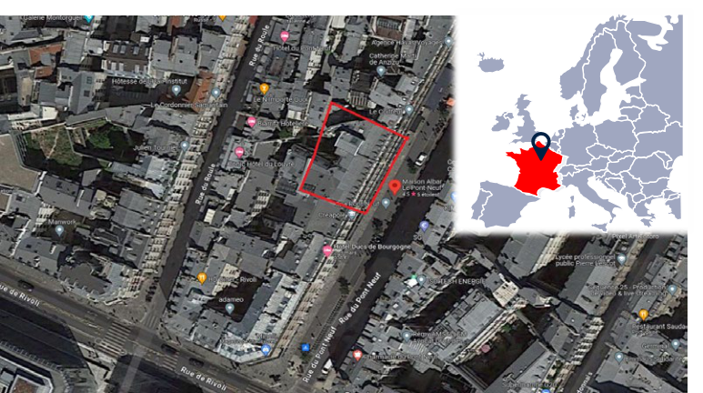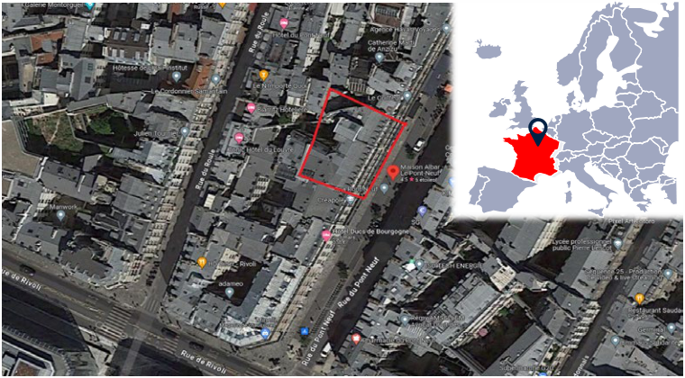

|  |  |
| --- | --- |
| **SAVILLS TECHNICAL DUE DILIGENCE RED FLAG AND CAPEX APPRAISAL** |  |

|  |  |  |  |  |  |  |  |  |  |  |  |  |  |
| --- | --- | --- | --- | --- | --- | --- | --- | --- | --- | --- | --- | --- | --- |
| **SUMMARY OF PROPERTY** |  | |  | | --- | | **Capex costs** | | | | | |  | |  | | --- | |  | | | | |
| |  | | --- | | **General information:** | |  |  |
| Property address: | 23/25 Rue du Pont Neuf, 75001 Paris, FRANCE | **€120 000**  **€100 000**  **€80 000**  **€60 000**  **€40 000**  **€20 000**  **€0** | |  | | --- | |  | | | | | **€100 000 €90 000**  **€80 000**  **€70 000**  **€60 000**  **€50 000**  **€40 000**  **€30 000**  **€20 000**  **€10 000**  **€0** |
| Purpose of TDD: | Red Flag TDD Report |
| Site visit date: | 16 November 2023 |
| Version - Report issue date: | 01.12.2023 |
| **A. Fabric** | | **B. Services** | | **C. Environmental** |
| **Service Charge recoverable** | | | **Capex / owner cost** | | **Year 1** | | **Years 2-5** | | **Years 6-10** |
| **Service Charge recoverable** | | | **Capex / owner cost** | |
| **Property information:** |  | |  |  |  |  |  |  |  |  |  |  |  |  |  |  |  |  |  |  |  |  |  |  |  |  |  |  |  |  |  |  |  |  | | --- | --- | --- | --- | --- | --- | --- | --- | --- | --- | --- | --- | --- | --- | --- | --- | --- | --- | --- | --- | --- | --- | --- | --- | --- | --- | --- | --- | --- | --- | --- | --- | | |  |  |  |  |  |  | | --- | --- | --- | --- | --- | --- | | **Element** | **Service Charge** | **Capex / owner** | | **Total** | | | **A. Fabric** | **recoverable** | **cost** | | € | 98 670 | | € 0 | € | 98 670 | | **B. Services** | € 0 | € | 69 575 | € | 69 575 | | **C. Environmental** | € 0 | € 0 | | € 0 | | | **Total** | **€ 0** | **€** | **168 245** | | | | | | | |  |  |  |  |  |  |  |  |  |  |  |  |  |  |  |  |  |  |  |  |  |  |  |  |  |  |  |  |  |  |  | | --- | --- | --- | --- | --- | --- | --- | --- | --- | --- | --- | --- | --- | --- | --- | --- | --- | --- | --- | --- | --- | --- | --- | --- | --- | --- | --- | --- | --- | --- | --- | | |  |  |  |  |  |  | | --- | --- | --- | --- | --- | --- | | **Year** | **Service Charge** | **Capex / owner** | | € | **Total** | | **Year 1** | **recoverable** | **cost** | | 0 | | € 0 | € 0 | | | **Years 2-5** | € 0 | € | 88 550 | € | 88 550 | | **Years 6-10** | € 0 | € | 69 575 | € | 69 575 | | **Total** | **€ 0** | **€** | **158 125** | | | | | | |
| Year of construction: | Original construction around 1850-1914 (according to the |
| Total surface area (m2): | BatiParis website). Last renovation November 2016. |
| To be verified |
| Number of levels: | 2 basement levels, ground floor and 6 upper levels. |
| Number of Keys: | 60 |
| Storey height: | 2.8 m in reception, 2.42 m to corridors, 2.17-2.40 m to | **CONCLUSIONS AND RECOMMENDATIONS** | | | | |
| Ceiling void: | guestrooms and 2.23 m in spa / gym. |
| 0.3 - 0.4 m (on-site measurement). |
| Floor loading: | Not assessed by Savills. | **General condition** | | | | |
| Front of house: | Reception hall, restaurant and courtyard at ground floor |

|  |  |  |  |
| --- | --- | --- | --- |
| level and with spa and gym / fitness room in basement 1.  basement level  masonry and painted wrought iron blaconies.  Windows and external doors: Timber framed with double glazing.  MEP installations: Mechanical & Electrical services required for a hotel building including Heating, Cooling, Ventilation, and Sanitary & Storm drainage, electrical lighting & power, and low voltage systems.  extinguishers throughout, automatic addressable fire  alarm system with smoke detection and manual call  stations next to fire exits, natural smoke extraction to  staircases and mechanical smoke extraction systems in  the spa / gym.  **savills.fr** | - The requirement to undertake façade painting and cleaning before 2026 as per the city of Paris regulation- Investigate and fix the source of the water ingress in the spa  2 | **Overall risk rating** | **01/12/2023** |

|  |  |  |
| --- | --- | --- |
| |  | | --- | | **Tenure / extent of demise** | | - Investigate and repair the cause of the mosaic tiles lifting in the swimming pool |
| Centaurus (formally Paris Inn) is the operator and owner of the hotel.  The hotel is operated under the Maison Albar brand, a 5-star luxury hotel brand. | - Implementation of BMS for BACS decree compliance |

|  |  |  |
| --- | --- | --- |
| Back of house: | Kitchen and offices at ground floor level, housekeeping | Overall the hotel is in satisfactory condition, typical with the age of construction. Full renovation was undertaken in 2016 to the building interiors and to the external envelope of the |
| office on each floor, laundry room and staff room at | hotel. |

|  |  |  |
| --- | --- | --- |
| Structure: | Solid load-bearing masonry and steel with concrete floors | The finishes fittings and services installations are in good condition. |
| reinforced with steel beams. | The maintenance programme by the operator is appropriate. Limited capex costs were identified by the Savills team. |
| Roof: |
| Pitched roof with zinc covering overthermal insulation; |
| Façades: | technical roof with built-up felt. Secure access to HVAC | The mechanical and electrical services were all replaced in 2016 and remain in good condition. We do not anticipate any major owner life cycle capital expenditure pertaining to |
| equipment on level 6 technical room with fixed ladder. |
| the mechanical & electrical installations for the next ten years. |
| Typical Paris Haussmanian façades with ashlar stone |

|  |  |  |
| --- | --- | --- |
| Domestic water services: | Cold water supply from a main metered connection to the | **Recommendations** |
| city utility water supply network. |
| Fire protection systems: | Dry risers with two outlet valves at each level, fire | From a TDD perspective, we see no reason why the proposed loan facility should not proceed. Key points to consider are:- |

|  |  |
| --- | --- |
| **SAVILLS TECHNICAL DUE DILIGENCE RED FLAG AND CAPEX APPRAISAL** |  |

|  |
| --- |
| **SUMMARY OF KEY OBSERVATIONS** |

|  |  |  |  |
| --- | --- | --- | --- |
| **Element** | **Key Consideration** | **Savills Comment** | **Risk Rating** |
| **A. Building Fabric** | | | |
| General | Generally the hotel is in a good condition and interior presents well throughout, reflecting a good quality renovation in 2016. The quality and the condition of the components and materials correspond to what is expected of a 5-star hotel. | No risk to lender. |  |
| Structure | The structure of the building is in good condition and no visible displacement, failure or damage was noted. | No risk to lender. |  |
| Roof | The roof zinc covering is in good condition (renovated in 2016). We saw no evidence of leaks and water damage. | No risk to lender. |  |
| Façades | The façades to the building (front and courtyard) appear in good condition. No major damage was noted. | Considering that the French Building and Housing Code "Code de la Construction et de l'Habitation" (CCH) in articles L. 126-2 and L. 126-3 requires façades of building in Paris are renovated every 10 years, we have allocated a cost for façade cleaning in the medium term. |  |
| Façades -  Flammability Risk | The hotel façades are made of solid masonry with internal thermal insulation so there is a low risk of flame spread as indicated in the Tristan Façade Fire Safety Risk Matrix. | No risk to lender. |  |
| External Areas | The courtyard terrace with garden is well maintained and in a good condition. | No risk to lender. |  |
| Internal Areas - Guestrooms | The finishes and fittings of the guestrooms are in a satisfactory condition. The interior is well maintained. | No risk to lender. |  |
| Internal Areas - Amenities | The finishes and fittings of the hotel amenities are in a satisfactory condition. However, the following minor defects have been noted:-  - The mosaic tiles in the swimming pool are lifting (re-occurring issue). There might be an issue with the compatibility with the waterproofing membrane.  - Water ingress is visible on the skylight above the pool. The waterproofing needs to be checked. | We have included an allowance for conducting an investigation to locate the source of the tile issue and water ingress and undertake necessary repairs. |  |
| Internal Areas - Reception Lobby | The finishes and fittings of the reception lobby are in a satisfactory condition. The interior is well maintained. | No risk to lender. |  |
| Back of House Areas | The finishes of the back of house are in a satisfactory condition. However, we have noted that the epoxy coating to the floor is lifting in several areas. | We have added a cost to reapply an epoxy coating to the affected areas. |  |
| **B. Services Installations** | | | |
| Cooling  production | The district cooling substation was installed in 2016 as part of the building overall renovation project. The system remains in good condition. | No capex anticipated in the next 10 years. |  |
| Heating  Production | The district heating substation was installed in 2016 as part of the hotel renovation project. The infrastructure remains in good condition. | No capex anticipated in the next 10 years. |  |
| Heating  Production | During the Savills site visit, there was a leak in one of the duct of the district heating substation. | The leak in the hot water pipework should be repaired in the short term. Cost falls under the maintenance Opex budget. No capex is anticipated. |  |
| Terminal treatment | The guest rooms and common areas terminal treatment (FCU’s and AHU’s) was installed in 2016 as part of the building overall renovation project. Installations are in good order. | No capex anticipated in the next 10 years. |  |
| Plumbing services | The plumbing services including the guest rooms water supply and drainage installations were installed in 2016 as part of the hotel renovation project. | The building plumbing services are in good condition. No Capital expenditure is anticipated in the long term. | |
| Electrical lighting & Power | The building is fully provided with LED lighting. The electrical power distribution was installed in 2016 as part of the hotel renovation project. Systems present well. | No capex anticipated in the next 10 years. |  |
| Low voltage systems | The electrical low voltage systems including access control, CCTV, intruder and telecommunication systems were installed in 2016 as part of the hotel renovation project. Systems present well in 2023. | No capex anticipated in the next 10 years. |  |
| BMS | A Daikin control system was installed in 2016 as part of the building overall renovation project, providing control and monitoring of the VRV system (guest rooms temperature set-points & operation, and room lighting control). The system is in good order. | No capex anticipated in the next 10 years. |  |
| BMS - BACS Decree | The asset is not equipped with a building management system (BMS). We recommend that a BMS is installed to comply with the Building Automation & Control Systems (BACS) decree. | Capex is provided in the long term for the installation of a BMS workstation, cabling and controls as the asset will be subject to this decree by January 1, 2027, given the nominal capacity of its HVAC systems. |  |
| Life Safety | The life safety systems including fire protection, fire alarm, and smoke extraction were installed in 2016 as part of the building overall renovation project. The systems present well. | No capex anticipated in the next 10 years. |  |
| Lifts | The lift machinery and tracking system were replaced in 2016 as part of the hotel renovation project. | No capex anticipated in the next 10 years. |  |

|  |  |  |
| --- | --- | --- |
| **savills.fr** | 2 | **01/12/2023** |

|  |  |
| --- | --- |
| **SAVILLS TECHNICAL DUE DILIGENCE RED FLAG AND CAPEX APPRAISAL** |  |
|  |  |

|  |  |  |
| --- | --- | --- |
|  | | |
| **savills.fr** | 3 | **01/12/2023** |

|  |  |
| --- | --- |
| **SAVILLS TECHNICAL DUE DILIGENCE RED FLAG AND CAPEX APPRAISAL** |  |

|  |  |
| --- | --- |
| **GENERAL INFORMATION** | |
| Property address: | 23/25 Rue du Pont Neuf, 75001 Paris, FRANCE |
| Purpose of TDD: | Red Flag TDD Report |
| Site visit date: | 16 November 2023 |
| Version - Report issue | 01.12.2023 |

|  |
| --- |
| **CAPEX ASSESSMENT** |

|  |  |  |  |  |  |  |  |  |  |
| --- | --- | --- | --- | --- | --- | --- | --- | --- | --- |
| **Element** | **Key Consideration** | **Savills Comment** | **Total** | **Short Term Year 1** | **Medium Term Year 2-5** | **Long Term Year 6-10** | **Service charge recoverable /**  **tenant cost** | **Capex / Owner cost** | **Risk**  **Rating** |
| **A. Building Fabric** | |  |  |  |  |  |  |  |  |
| **A.1. Structure** | |  | **€ -** | **€**  **-** | **€ -** | **€ -** | **€ -** | **€**  **-** |  |
| 1 | No defect identified. | No capex allowance required for the next ten years. | € - |  |  |  | € - | € - |  |
|  |  |  |  |  |  |  |  |
| **A.2. Roofs** | | **Sub-total** | **€ -** | **€**  **-** | **€ -** | **€ -** | **€ -** | **€**  **-** |  |
| 1 | No defect identified. | No capex allowance required for the next ten years. | € - |  |  |  | € - | € - |  |
|  |  |  |  |  |  |  |  |  |  |
| **A.3. Facades** | | **Sub-total** | **€**  **50 000** | **€**  **-** | **€ 50 000** | **€ -** | **€ -** | **€**  **50 000** |  |
| 1 | The facades to the building appear to be in good condition with no major defects. In accordance with the regulation, the cleaning of the facades is required every 10 years. As the last renovation was done in 2016, the cleaning of the facade would be required before 2026.  No defects seen to courtyard façades. | We include a small capex for the future cleaning and repainting of the main facades in the medium term. | € 50 000 |  | € 50 000 |  | € - | € 50 000 |  |
|  |  |  |  |  |  |  |  |  |  |
| **A.4. External Areas** | | **Sub-total** | **€ -** | **€**  **-** | **€ -** | **€ -** | **€ -** | **€**  **-** |  |
| 1 | No defect identified. | No capex allowance required for the next ten years. | € - |  |  |  | € - | € - |  |
|  |  |  |  |  |  |  |  |  |  |
| **A.5. Internal Areas** | | **Sub-total** | **€**  **28 000** | **€**  **-** | **€ 20 000** | **€ -** | **€ -** | **€**  **28 000** |  |
| 1 | The mosaic tiles in the pool are lifting (reccurent issue). There might be an issue with the compatibility with the waterproofing membrane. | We allowed for the appointement of a pool wpecialist to identfy the issue with the lifting tiles and undertake the necessary repairs. | € 10 000 |  | € 10 000 |  | € - | € 10 000 |  |
| 2 | Water ingress is visible on the skylight above the pool. The waterproofing needs to be checked. | We allowed for the appointement of a waterproofing specialist to identify the location of the water ingress and undertake the necessary repairs to the waterproofing. | € 10 000 |  | € 10 000 |  | € - | € 10 000 |  |
| 3 | The epoxy coating applied on the floor of the back of house areas is lifting. | We include an allowance to reapply the epoxy coating to the affected areas. | € 8 000 |  |  |  | € - | € 8 000 |  |
|  |  |  |  |  |  |  |  |  |  |
| **B. Services Installations** | |  |  |  |  |  |  |  |  |
| **B.1. Heating, Ventilation and Cooling (HVAC)** | | **Sub-total** | **€ -** | **€**  **-** | **€ -** | **€ -** | **€ -** | **€**  **-** |  |
| 1 | No defect identified. | No capex allowance required for the next ten years. | € - |  |  |  | € - | € - |  |
|  |  |  |  |  |  |  |  |  |  |
| **B.2. Electrical Installations** | | **Sub-total** | **€**  **55 000** | **€**  **-** | **€ -** | **€ 55 000** | **€ -** | **€**  **55 000** |  |
| 1 | We recommended that a BMS is installed to comply with the Building Automation & Control Systems (BACS) decree. | Capex is provided in the long term for the installation of a BMS workstation, cabling and controls as the asset will be subject to this decree by January 1, 2027, given the nominal capacity of its HVAC systems. | € 55 000 |  |  | € 55 000 | € - | € 55 000 |  |
|  |  |  |  |  |  |  |  |  |  |
| **B.3. Domestic Water Services** | | **Sub-total** | **€ -** | **€**  **-** | **€ -** | **€ -** | **€ -** | **€**  **-** |  |
| 1 | No defect identified. | No capex allowance required for the next ten years. | € - |  |  |  | € - | € - |  |
|  |  |  |  |  |  |  |  |  |  |

|  |  |  |
| --- | --- | --- |
| **savills.fr** | 3 | **01/12/2023** |

|  |  |
| --- | --- |
| **SAVILLS TECHNICAL DUE DILIGENCE RED FLAG AND CAPEX APPRAISAL** |  |
|  |

|  |  |  |
| --- | --- | --- |
| Risk Rating Key | | |
| **savills.fr** | The Capex budget does not include minor repairs and a threshold of €5,000 is used for this report. Cost items below this threshold have not been included in the Capex. Our Capex does not include routine maintenance, cyclical decoration or cleaning, except where these works are required to address defects or compliance issues.  4 | **01/12/2023** |

|  |  |
| --- | --- |
| High | Significant issue where an urgent remedy is required prior to the proposed property transaction or a serious defect requiring attention. |
| Medium | Key issue to be clarified and/or fully considered in relation to the proposed property transaction or repairs having a significant cost implication. |
| Low | A minor issue which is not considered to constitute a material issue in the short term. |

|  |  |
| --- | --- |
| **SAVILLS TECHNICAL DUE DILIGENCE RED FLAG AND CAPEX APPRAISAL** |  |

|  |  |  |
| --- | --- | --- |
|  | | |
|  | **PHOTOS** |  |
|  |
|  |  |  |
| **savills.fr** |  | **01/12/2023** |

|  |  |  |
| --- | --- | --- |
| **SAVILLS TECHNICAL DUE DILIGENCE RED FLAG AND CAPEX APPRAISAL** | |  |
| Garth Ball MRICS | Aurelie Hubert |  |

|  |  |
| --- | --- |
| Director Building Consultancy  LD: +33 1 86 69 39 23  M: +33 6 03 49 03 59  [ghough@savills.com](mailto:ghough@savills.com) | Building surveyor  LD: +33 1 86 69 39 23  M: +33 6 29 49 56 04  [aurelie.hubert@savills.fr](mailto:aurelie.hubert@savills.fr) |

**savills.fr**